**MALAIKA NURSERY AND PRIMARY SCHOOL END OF TERM III EXAMINATION 2023**

**TOP CLASS: (5 – 6 YEARS)**

**LEARNING AREA 4: MATHEMATICAL CONCEPTS**

**My name is: ………………………………..………………………….**

**My School is: ……………………………..……….…………………..**

**I am in: ………………………………..…………………………………………..**

1. **Read and draw pictures.**

|  |  |  |
| --- | --- | --- |
| five cups | three books | two girls |
|  |  |  |
| six stools | seven flowers | four boys |
|  |  |  |

1. **Fill in the missing number.**

12 , _______, 14 , _______, _______, 17

19 , ________, ________, ______, 23, ______

35 , ______, ________, 38 , ________, _______

1. **Add these numbers.**

2 + 5 = ______

7 + 7 = ______

3 + 9 = ______

8 + 0 = ______

6 5 I0

+4 +5 +7

1. 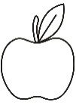**Count and write in words**.

= ____________

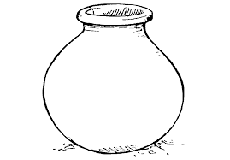

= _____________



= _____________

= ______________

= ______________

1. **Take away**.

5 - 2 = ______

I0 - 4 = ______

I2 - 6 = ______

1. **Draw for the numbers.**

4 =

6 = _____________________________________

3 = ______________________________________

0 = ______________________________________

I0 = _____________________________________

1. **Write the number before.**

_______ 3 _______ 6

_______ I _______ 9 ________ II

1. **Make small sets.**

***“Good Luck”***